Title of Activity:
Large group: Repeated Connected Reading and Retelling
Parent Engagement at FPG: Reading at home
First, choose a book that lends itself to children reading as a whole group, like The Little Red Hen by Byron Barton. Look for repetitive text, a juicy problem in the plot, and concepts to practice like math or rhyming words. In the example below, math concepts are highlighted but if rhyming was in the text it would be explored on the fourth reading.
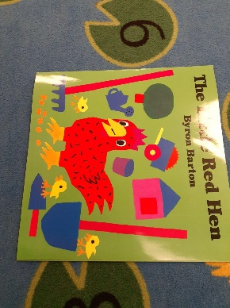
First Read- discuss (show) the parts of the book (author, illustrator, title, spin, front and back covers)
Pre-read questions (beginning of the book’s initial endpapers): what do you see? Where does this story take place? Have you ever been to a farm?
While reading questions: what are the pig, cat, and duck doing? What are the hen and chicks doing? What do you think will happen next? What do you think the hen will do? What else do you notice is happening?
Discuss vocabulary: thresh, wheat, grain, flour, grind (as necessary for your group)
Invite children to act out: planting seeds, cutting wheat, threshing wheat, grinding grain, baking bread, etc.
Post-reading questions: What was the problem in this book? Why do you think the hen didn’t share the bread? What do you think about who ate the bread? (be ready to discuss sharing, fairness, and caring… be ready for children respond with loving hearts and say to share the bread anyway 🙂)
Between first and third readings at small group time(s): have children create characters from the story. It could be simple as shown below or elaborate puppets that are created over several small groups. Recall who the characters were. Give the children choices about which one(s) they create. Discuss features of those characters. Discuss the process of creating a character. Recall what the characters did or said in the story while working.
.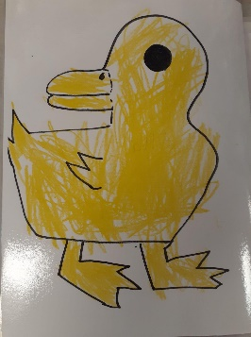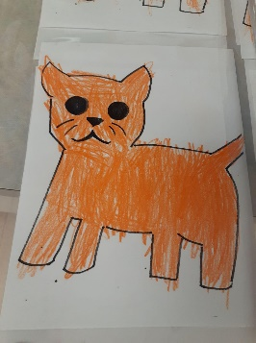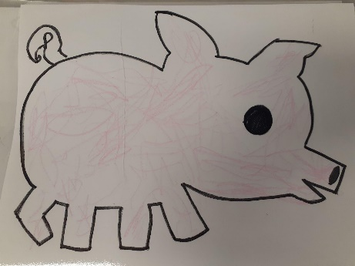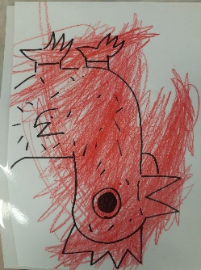
Second Read- review the author and illustrator. discuss where to start reading the book and direction of reading the text as you point. Invite the children to read the words with you by character. point out the words the pig, cat, duck say (Not I) and have children practice them. point out the word the hen says (who will help me) and have children practice them.
Pre-reading questions: Help me remember, where does the story take place? Who are the characters?
While reading questions: How does the hen feel when…? How does that cat, duck, pig feel when…? Discuss feeling words (try to get beyond happy and sad): when animals are playing (excited, happy, etc.) when animals are sleeping (tired) when hen is working (tired) when hen has baked the bread (proud) when animals don’t get bread (disappointed)
Invite children to read the words as you point to them while reading the story and pause.
Review vocabulary as needed
Post-reading questions: How would you feel if you didn’t get any bread? How would you feel if you saw hen working while you were playing (flying a kite, riding in a wagon, rowing the boat)? What would you do if hen asked you to help?
Now, what do you think about who ate the bread? (be ready to discuss sharing, fairness, and caring… be ready for children to respond with loving hearts and say to share the bread anyway 🙂) Last time, we talked about the problem in the book (some animals didn’t help, hen didn’t share, whatever the children said). What is the solution to this problem? What could the animals who didn’t help say or do to get some bread? (ask nicely, promise to help next time, offer to help clean up since they didn’t help prepare… be ready for children to problem solve with unique ideas)
Third Read-
Pre-reading questions: Ask children to point out the parts of the book(author, illustrator, title, spin, front and back covers) and where to begin reading. Review the direction of reading the text again.
Invite children to take the lead in reading the book. Have the children “read” the story page by page. begin by having the whole group “read” a few pages, then have individuals volunteer to read a page.have a child point out the words the pig, cat, duck say (Not I) and have children practice them. point out the word the hen says (who will help me) while the children read those words. If you have a child who is reading words, be sure to invite them to read a page suited to them.
While reading questions (since you are the audience, try to pose questions as a listener): What is happening there (noticing illustration)? What does that mean (inquiring about vocabulary)?
Vocabulary: thresh, wheat, grain, flour, grind (as necessary for your group)
Post-reading questions: How did it feel to read the book? What do you know about reading? Return to the problems/solutions to see if children who haven’t spoken up yet have ideas to share. Check to see if children have new insights or feelings.
Fourth Read-
Pre-reading questions: Where is the title? (find it on cover and first page) How many words are in the title? (count and point) How many words in the author’s name? (count and point)
While reading questions: How many friends are… (flying the kite)? How many seeds did hen plant? How many chicks help hen?
Vocabulary (check your vocabulary list to be sure it is what children are in need of practicing): thresh, wheat, grain, flour, grind (as necessary for your group)
Invite children to show you the numbers of things you are counting in the story on their fingers. Invite them to show you that number another way (i.e. three can be 3 fingers on one hand OR it can be 1 finger on the right hand and 2 fingers on the left hand.)
Post-reading questions: What are the steps the little red hen did to make the bread? (first, plant; second, cut; third, thresh; etc. ) Hold up fingers as they name the sequence. What things did cat, duck, and pig do? (first, boat; second, wagon; etc.) Turn back to the book to review as the children name them.
Return to the problems/solutions to see if children who haven’t spoken up yet have ideas to share. Check to see if children have new insights or feelings.

After third or fourth reading at small group time(s):
Have children draw their favorite part of the story on a blank paper. Invite them to label or write their dictations. This may need to be done in two small group times. Once complete after fourth reading, invite the small groups to sequence the pictures they drew and retell the story with their illustrations. Again, this may take several small group times. Once the order is complete, staple the pages together and put the book in the classroom library. Encourage the children to read it during choice time.
Leave the characters the children created out with the original book so they can retell the story throughout the day.
Family engagement at FPG meeting:

Discuss with families the poster below
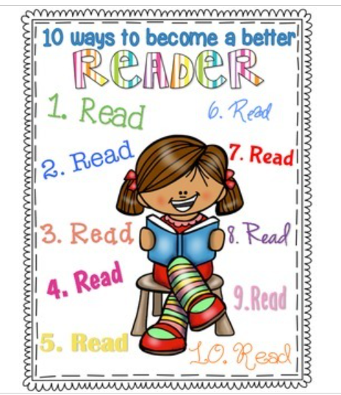
10 Ways to Become a Better Reader {FREEBIE} by The Reading Bungalow (teacherspayteachers.com)
Discuss with families how children need to be read to and independent reading is also important. Independent reading can happen in three ways. Share this poster (be sure to note copyright limits).
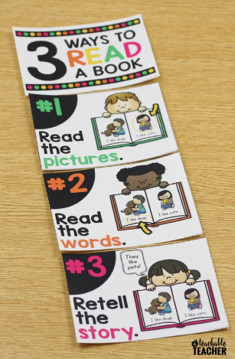
https://www.ateachableteacher.com/free-three-ways-to-read-a-book-posters/
Have a book ready to read aloud to the children. The book could be at any stage of reading. If you are reading the book to the children for the first time, you will be modeling concepts of print, asking questions before, during, and after reading to show the conversation it yields. You can share this article from Readingrockets.org with families:
https://www.readingrockets.org/article/use-peer-when-you-read-aloud
If you have read the book several times with the children they could do most of the reading or retelling. In this case, share with families a synopsis of the repeated read alouds and small group connections the children did in school. A slidedeck or photo book documenting the process would be cool to share!

